

**Daffodil International University**

Project Report

**Project Title: Portfolio Website**

Course Name: Web Engineering

Course Code: CSE415

**Submitted to**

Johora Akter Polin

Lecturer

Department of CSE

Daffodil International University

**Submitted by**

Asraful Islam

ID: 191-15-12515

Section: L

Submission Date: April 10th  2022

**Abstract:**

It’s a website of my portfolio. In this section, people can write about themselves, their field of work, or work experience. It's incredibly helpful to be able to respond to someone in a short amount of time. Understands a variety of topics, such as among other things what we do, our services or what we offer, and what we have done so far.

**Background:**

**\*Admin Panel:** The term Admin refers to the owner, who is also the one providing service as the portfolio owner. He has ultimate control over this website. According to the requirements, he has the authority to add or remove items. The site will show which fields he excels in.

**User Panel:** The user is those who are seeking to hire someone to help them with an assignment or work. The user can examine the work on this site to determine whether or not he is the perfect person. Then he can go to the following step, which is contacting the programmer or developer.

**Methodology:**

Portfolios are an excellent way for me to demonstrate rather than just tell about the skills I'd include on a CV or discuss in an interview; they allow me to Demonstrate rather than Just tell about the skills I'd Include on a CV or Discuss in an interview. During a job search, the portfolio is used to present my work to prospective employers. It demonstrates my relevant abilities and talents. Time management, cost management, quality management, and communication are just a few of the knowledge areas briefly covered in this project.

**Implementation:**

Having a portfolio can improve your recognition in a professional or academic setting.

* **Frontend:**
* HTML
* CSS
* JavaScript
* **Database:**
* SQLite
* **Backend:**
* Django

**Advantages:**

1. Makes Right Investment Choice
2. Maximizes Return
3. Track Performance
4. Manages liquidity
5. Avoid Risk
6. Improves Financial Understanding

**Challenges:**

We have plans to add more features that will be helpful for users.

**Future of the Project:**

I'll keep adding additional work experience and projects to this page. This will assist people who are looking for someone with experience to complete their work. And this will increase the worth of my real-world work as well as my C.V.

**A glimpse of my project:**

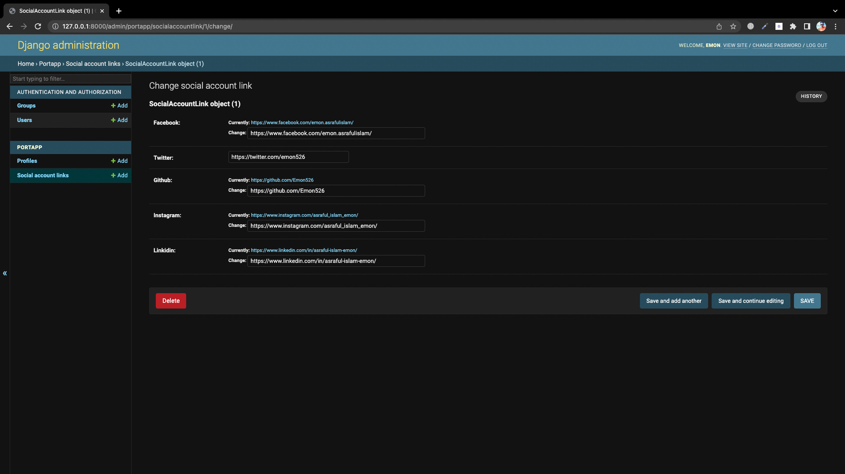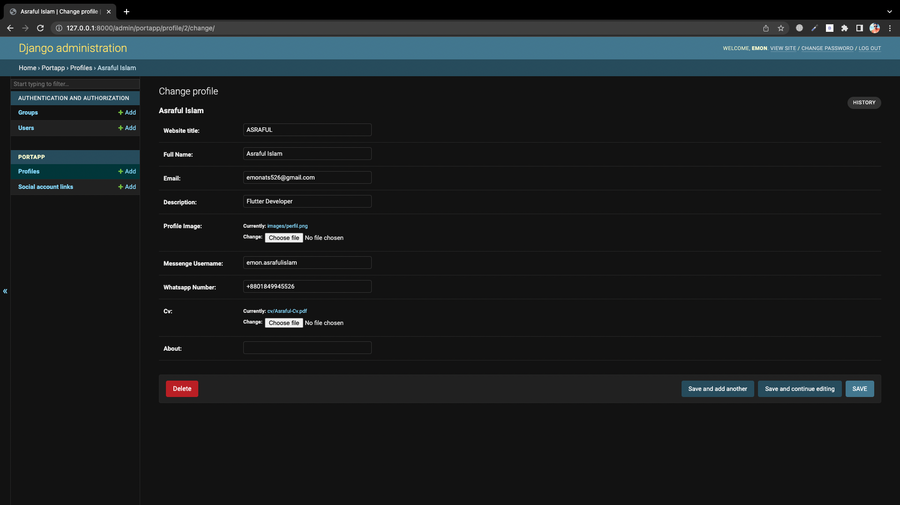**Admin Panel :**

**User Panel (Dark & Light Theme) :**

